Dipartimento di Ingegneria e Scienza dell’Informazione

Assignment Title – Step 1

Document data: | Reference persons:
dd.mm.yyyy | Name, Familiy Name - Student ID; …

© 2017 University of Trento
Trento, Italy

KnowDive (internal) reports are for internal only use within the KnowDive Group. They describe preliminary or instrumental work which should not be disclosed outside the group. KnowDive reports cannot be mentioned or cited by documents which are not KnowDive reports. KnowDive reports are the result of the collaborative work of members of the KnowDive group. The people whose names are in this page cannot be taken to be the authors of this report, but only the people who can better provide detailed information about its contents. Official, citable material produced by the KnowDive group may take any of the official Academic forms, for instance: Master and PhD theses, DISI technical reports, papers in conferences and journals, or books.

Index

1. Assignment description 4
2. Scenario 4
3. Personas 4
4. Storytelling definition 4
5. Queries and generalized queries 5
6. Data Sets 6
7. Extended Entity Relationship Model (EER) 6

Revision History

Revision | Date | Author | Description of Changes
0 | dd.mm.yyyy | Name | Text
… | … | … | …

Layout

- Paragraphs. Times Roman size 12 should with line spacing 1,0 be used.
- Sections. Times Roman size 14.
- Title. Times Roman size 28.
- Footnotes. Put footnotes at the bottom of the page and use 9 points text. They may be numbered or referred to by asterisks or other symbols. Footnotes should be separated from the main text by a line.
- Illustrations. Place figures, tables, and photo-graphs in the paper near where they are first discussed, rather than at the end, if possible.
- Captions. Provide a caption for every illustration; number each one sequentially in the form: “Figure 1. Caption of the Figure.” “Table 1. Caption of the Table.” Type the captions of the figures and tables below the body, using 11 point text.
- Margins and Gaps are already defined by the current doc.

Assignment description
This section contains the description of the assignment. The assignment description should contain the name of the topic and the description of the datasets related to the assignment.
The list of topics and related files can be found in the KDI Assignment Index Slides
The assignment description should not be shorter than ½ page and longer than one -page.

Scenario
In what follows a detailed description of a scenario related to the selected topic should be provided.
The scenario is a description of the situation that tells how the storytelling will be developed. It is in plain text. It is like telling a story to a kid describing a real world scenario with real needs, real people, real action. People should have names, an age, gender specified, roles, and should take action. This action should be what the demo shows we can support with the system.
The scenario description should not exceed the maximum of a page and be at least ½ page .

Personas
Personas should be real people, but at the same time they should be representative of the role they represent. The personas should be extracted from the scenario above, with their names etc etc. There should be max 20 lines of description per persona. This part should make explicit what is already implicit in the scenario description namely, their role in life, why they should be interested in the system, and in which modalities they would like to use it.

Storytelling definition
This part should be the breakdown/expansion of the scenario described above. It should be an itemized sequence of steps with three components:
- The persona
- The real world action/goal of the persona
- The corresponding action by the system/demo which support the persona in doing what she needs to do

Persona | Real World action by persona | System/demo action
Name | Action 1 by persona | Action 1 by system/demo
… | … | …

Tab. 1

This section should not be longer than 5 pages (and not be shorter than 3 pages).
[One scenario per persona issue]

Queries and generalized queries
In this section the actions listed in the section above should be formalized into (generalized) queries. For queries we suggest to create a second table which reports how queries can be generalized from the actions in the plot above. This leading to the following second table.

Persona | (Generalized) Query | (Expected) Answer
Name | (example) Give me articles with “computer vision” as topic and “pdf” as format | (example) A page with a list of papers in pdf format
… | … | …

Tab. 2
This section should not be longer than 2 pages (and not be shorter than 1 page).

Data Sets
This section should describe/list the data sets used to populate the EER Model.
A full list of the datasets to be used along with a brief explanation (for each dataset) should be provided. The data section should not be longer than a page and not shorter than ½ page.

Extended Entity Relationship Model (EER)
This section provides the diagram that represents the main output of the assignment step 1, i.e., the EER model.
The EER model should be extracted from the queries above and organized in three levels of decreasing importance:
- Core entity types (plus relations and attributes)
- Auxiliary entity types (plus relations and attributes)
- Common entity types (plus relations and attributes) (e.g, space, time)
The ER model should be depicted using the yed tool.
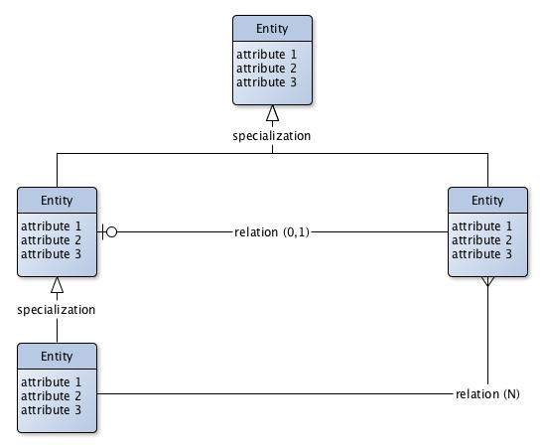
Fig. 1. An example of EER model with reference notation
A motivation for the selected core, auxiliary and common etypes should be provided, along with an explanation of what datasets information have been used.
This section should not be shorter than a page and no longer than 3 pages.

This is how a footnote should appear.
Note the line separating the footnotes from the text.

